## Problem 3. Target Multiplier

Write a program which reads from the console **dimensions of a matrix** and **matrix elements values**. Get a **targeted cell** and **multiply** **its value** with **the sum of all neighboring cells**. The **neighboring cells** must **change their values too**. **Each one** should be **the product** of **its initial value** and **the initial value of the targeted cell**. Then **print on the console updated matrix**.

### Input

The input data should be read from the console:

* The **first line** holds the number of **rows – R** and **columns – C,** separated by space.
* The **next R lines** hold the **matrix values**. Each line holds **C** **integers**, separated by space.
* The **last line** holds **the position** (targeted **row** and targeted **col**) **of the targeted cell**, separated by space

The **input data will always be valid** and in the format described. **There is no need to check it explicitly**.

### Output

The output should be printed on the console. The elements of each row should be separated by space.

### Constraints

* The **dimensions** of the matrix **(R and C)** will be a **positive integer numbers** in the range **[3...20]**.
* The **values of the cells** will be an **integer numbers** in range **[-16,300... 16,300]**.
* The **targeted row** will be an **integer number** in the range **[1...R-2]**.
* The **targeted column** will be an **integer number** in the range **[1...C-2]**.

### Examples

|  |  |  |
| --- | --- | --- |
| **Input** | **Output** | **Comments** |
| 5 5  10 12 14 16 17  10 12 14 16 17  10 12 14 16 17  10 12 14 16 17  10 12 14 16 17  2 2 | 10 12 14 16 17  10 168 196 224 17  10 168 1568 224 17  10 168 196 224 17  10 12 14 16 17 | Targeted cell is [2,2] = 14  The sum all neighboring cells is:  12 + 14 + 16 + 12 + 16 + 12 + 14 + 16 = 112  The targeted cell new value = 14 * 112 = 1568  Neighboring cells new values:  [1,1]=12*14=168; [1,2]=14*14=196; [1,3]=16*14=224;  [2,1]=12*14=168; [2,3]=14*14=224;  [3,1]=12*14=168; [3,2]=14*14=196; [3,3]=16*14=224 |
| **Input** | **Output** | |
| 6 4  0 105 420 480  1 143 624 744  2 182 628 488  3 226 326 538  4 263 376 406  5 -1 -2 -3  4 2 | 0 105 420 480  1 143 624 744  2 182 628 488  3 84976 122576 202288  4 98888 659128 152656  5 -376 -752 -1128 | |

# Solution

## Read Input

First of all we need to read the input. On the first line we receive the dimensions of the matrix

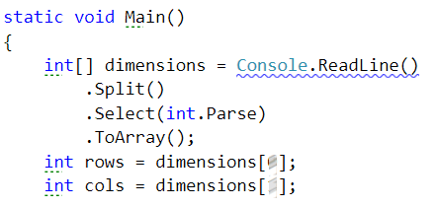

Now we need to define a structure that will hold our array and fill it with values.

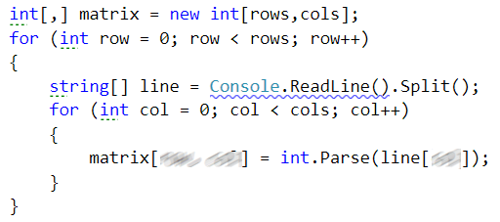

Last thing that left to read from the input is the location of the target cell.

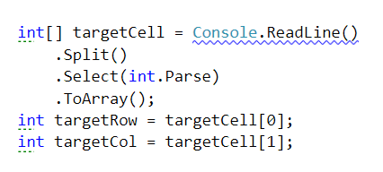

## Calculate Sum of Neighbor Cells

We need set start and end indexes for the rows and cols for target cell neighbors

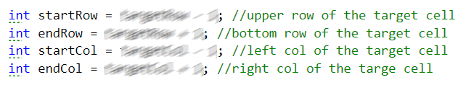

No we should find the sum of the neighbors of the target cell.

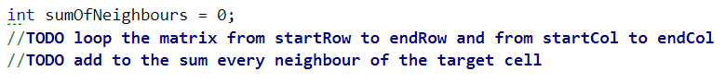

## Change Value of Target Cell and Its Neighbors

Now we need to keep the original value of the target cell

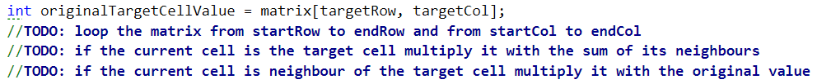

## Print Result

Finally, we print the matrix.

